PayPal Instructions

BioMedSA uses PayPal to process credit card transactions for events. You do not need to have a PayPal account to make a purchase. Please follow the instructions below.

- You will see this text for payment options. As you can see, BioMedSA uses PayPal to process. You will be directed to PayPal to complete your transaction. You will have the ability to check out as a guest.
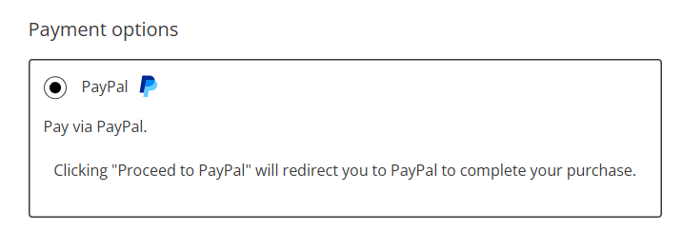
- Select ‘Pay with a Debit or Credit Card

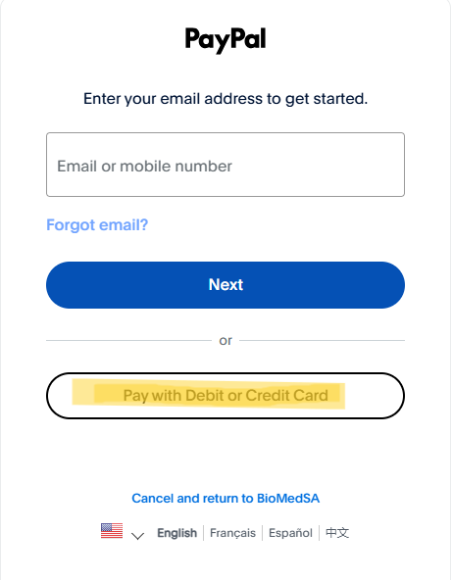

- Enter your email. This step is necessary for you to receive a receipt for your purchase.
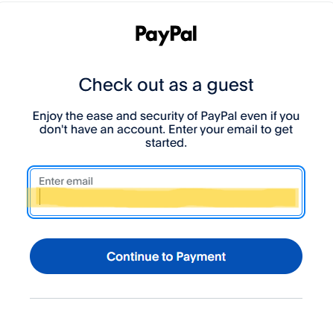

- Complete the information requested. At the bottom of the page you will see the following: UNCHECK the box that says ‘Create my PayPal account.
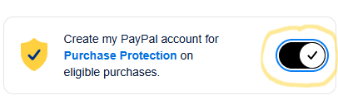
It will look like this. Click ‘Pay Now’ to complete the transaction.
